# Python Programs Explanation

## 1. Luhn Algorithm (Credit Card Validation)

### How it Works:

- The card number is split into digits.  
- The last digit is separated as the check digit.  
- The remaining digits are reversed, and every second digit is doubled.  
- If doubling makes a number greater than 9, 9 is subtracted.  
- All digits are summed with the check digit.  
- If the total is divisible by 10, the card is valid.

### Why this Approach is Used:

- Luhn Algorithm is a standard way to validate credit card numbers.  
- It detects common typing errors or invalid numbers.

### Output

According to my card number my output is **Invalid Card.**

## 2. Remove Punctuation

### How it Works:

- A string of punctuation marks is defined.  
- The function iterates over each character in the input string.  
- Only characters that are NOT in punctuation are added to the result.  
- This removes unwanted punctuation and cleans the text.

### Why this Approach is Used:

- Useful in text preprocessing (e.g., Natural Language Processing).  
- Helps to clean data for further analysis.

### Output Screenshot:

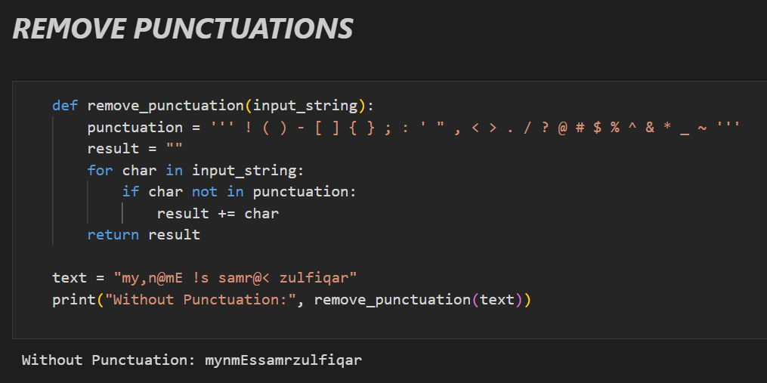

In this code I cannot use “ \ ” back slash because it give some writing syntax warning .

## 3. Sort by Word

### How it Works:

- The sentence is split into words.  
- A bubble sort algorithm is used to compare words.  
- Words are compared in lowercase to ensure case-insensitive sorting.  
- Finally, words are joined back into a sorted sentence.

### Why this Approach is Used:

- Helps in organizing words alphabetically.  
- Useful in applications like dictionary creation or text arrangement.

### Output

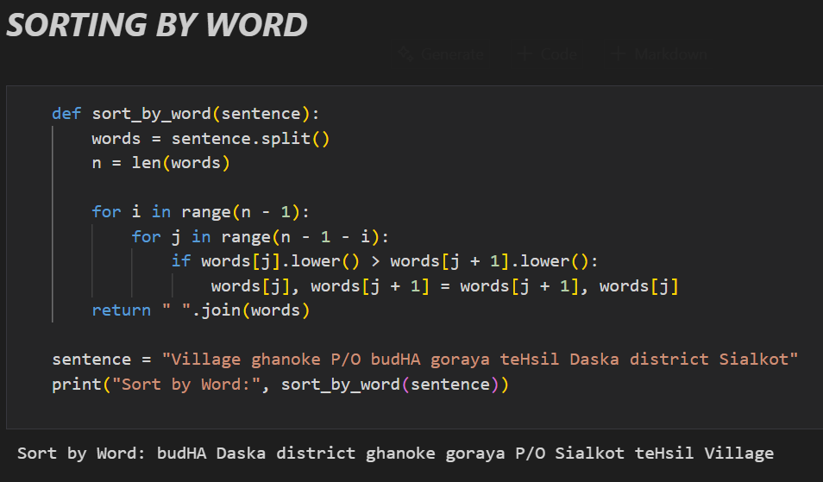

## 4. Sort by Letter

### How it Works:

- All alphabetic characters are extracted from the sentence.  
- Bubble sort is applied to arrange letters in alphabetical order.  
- The sorted letters are then joined into a new string.

### Why this Approach is Used:

- Useful when analyzing frequency or order of letters.  
- Helps in text manipulation and cryptography-related tasks.

### Output

